NAME: ALEJANDRO PANTOJA-ZURITA
CLASS: CSC 210 – SYSTEM PROGRAMMING
ASSIGNMENT: MODULE 2 – LAB 2 – LINUX COMMAND PRACTICE
INSTRUCTOR: TIAN Z. DING.
DATE: SEPTEMBER 3, 2025

LINUX COMMANDS
- “ls” command - Lists the contents of a directory (files and subdirectories)
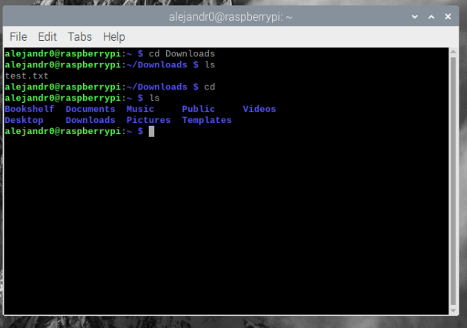
- “cd” command - Changes the current working directory.
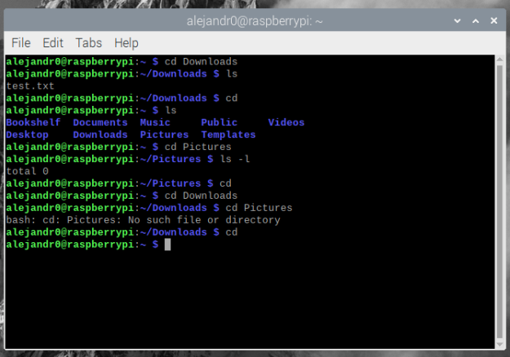
- “mkdir” (make directory) command - Creates a new directory.
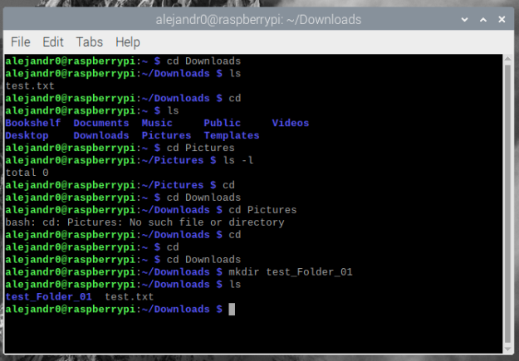

- “rmdir” (remove directory) command - Removes an empty directory.
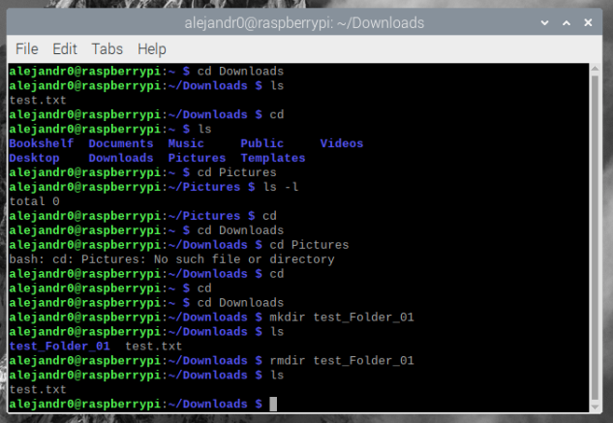
- “rm” (remove) command - Deletes files or directories. Use with caution.
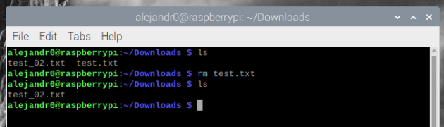
- “chmod” (change mode) command - Changes the permissions of a file or directory.
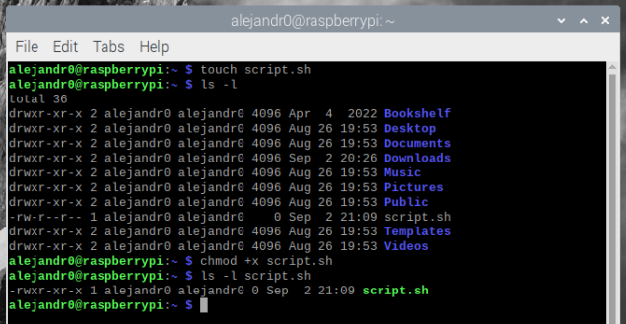
- “mount” command - Mounts a filesystem to a directory.
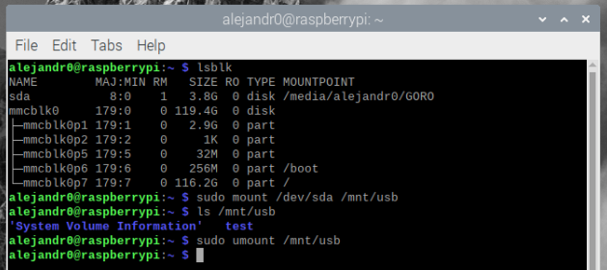
- “cp” command - Copies files or directories.
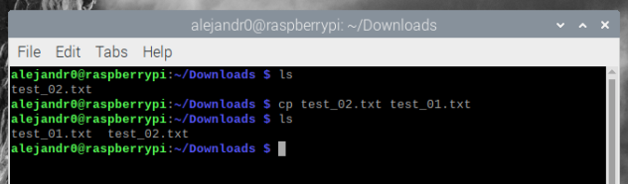
- “mv” command - Moves or renames files and directories.
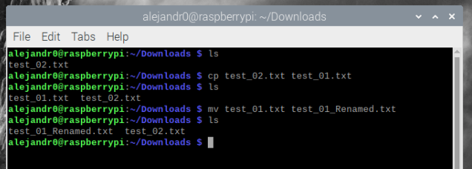
- “find” command - Searches for files and directories in a directory hierarchy.
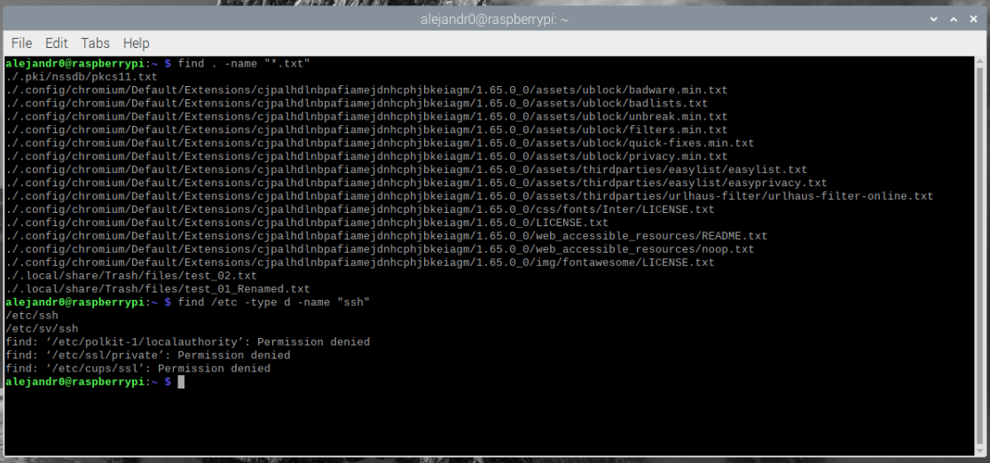
- “paste” command - Merges lines of files side by side.
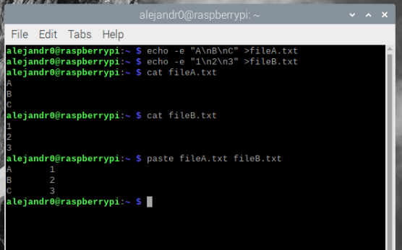

- “cut” command - Extracts specific columns or fields from a file or input.
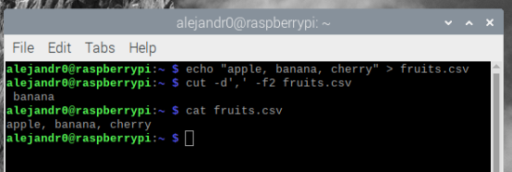
- “sort” command - Sorts lines in a text file.
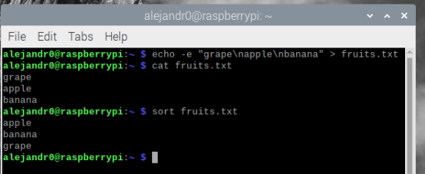
- “join” command - Joins lines of two files on a common field.
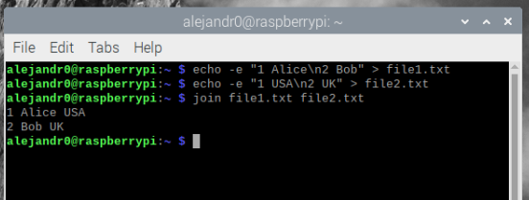
- “awk” command - A powerful text processing tool used for pattern scanning and processing.
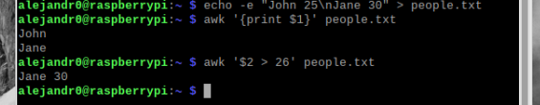
- “touch” command - Creates an empty file or updates the timestamp of a file.
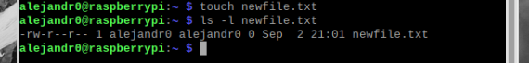

- “|” (Pipe) operator – Passes output of one command as input to another.
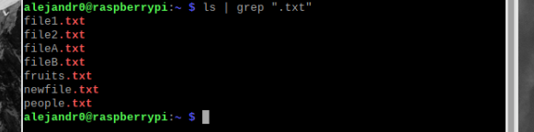
- “<” (input redirection) operator – Takes input from a file.
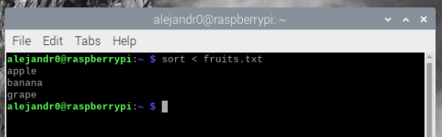
- “>” (output redirection) operator – Writes output to a file (overwrites).
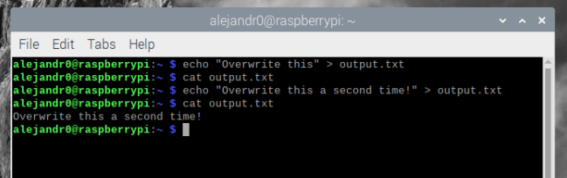
- “>>” (append redirection) operator – Appends output to the end of a file.
